# Environment Setup

1. Install JDK 13 available at <https://www.oracle.com/technetwork/java/javase/downloads/jdk13-downloads-5672538.html>
2. Download maven available at <https://maven.apache.org/download.cgi>
3. Setup variables : Follow this guide <https://www.mkyong.com/maven/how-to-install-maven-in-windows/>

## What I did for environment variables

Maven version can differ here based on the version you download but it doesn’t matter

1. Goto my PC and right click.

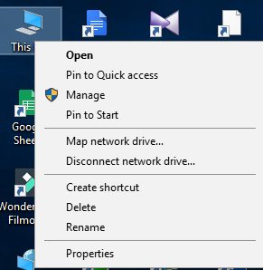

1. Click on properties
2. Window like this opens up. Select link highlighted in Red

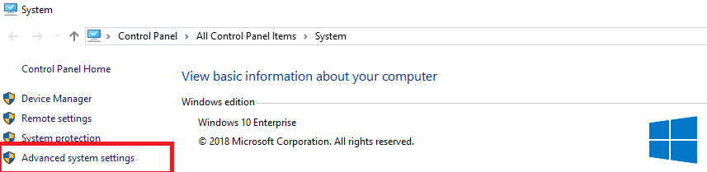

1. Select Environment Variable on the next pop up

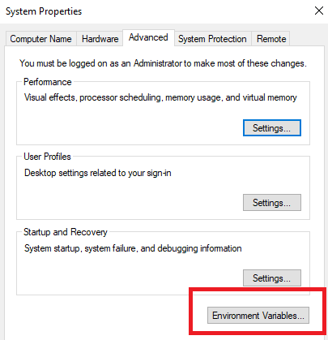

1. Add these two variables in system variables

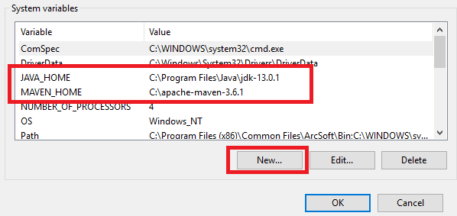

1. Select path and click on edit button

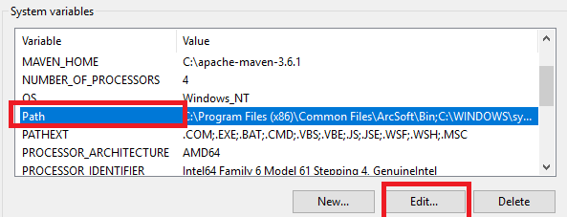

1. Add these two variable on the next pop up in the same order for the two

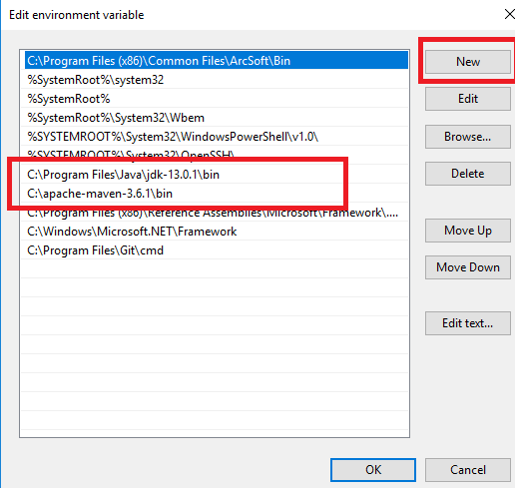

# User Configuration

1. Open Login.Json placed at .\\src\main\java\com\travian\qa\config\

It looks like below

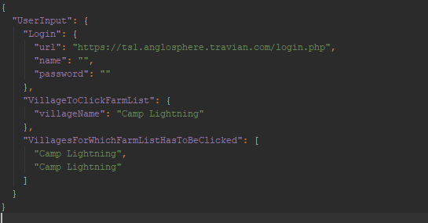

1. Add your URL, name and password
2. Village Name under VillageToClickFarmList is that village which the script will select from village lists on the right side of screen, make sure this is the village will maximum building to let the randomization work.
3. Under VillagesForWhichFarmListHasToBeClicked add all the villages in double quotes (“YOUR_VILLAGE_NAME”) for which the farm list has to be clicked. The scripts checks the check box and click on send raid button for all those villages mentioned here.